How are revenue, number of orders, and average order value changing over time?
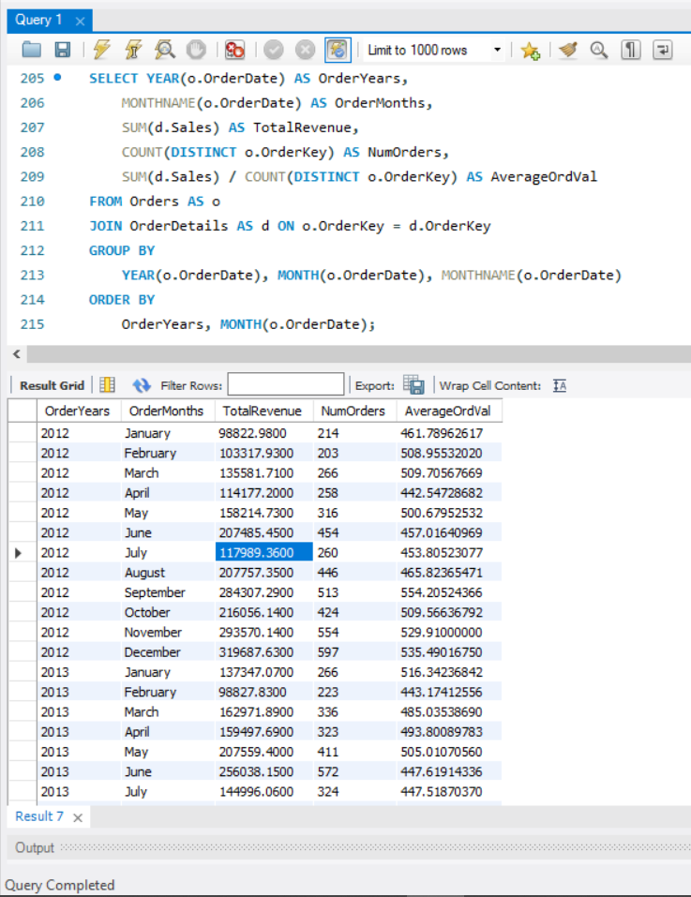

Business Insight:
Based on the data, it is evident that the company has been experiencing steady growth over the years. Although revenue does not increase every single month consecutively, the overall long-term trend remains highly positive. When analyzing the metrics further, we can see that this growth is primarily driven by a rising number of orders, indicating successful customer acquisition or higher frequency of purchases. In contrast, the average order value fluctuates slightly but remains relatively flat, meaning that the expansion is volume-driven rather than a result of customers spending more per transaction.

Who are the top 10 customers by revenue, and how profitable are they?
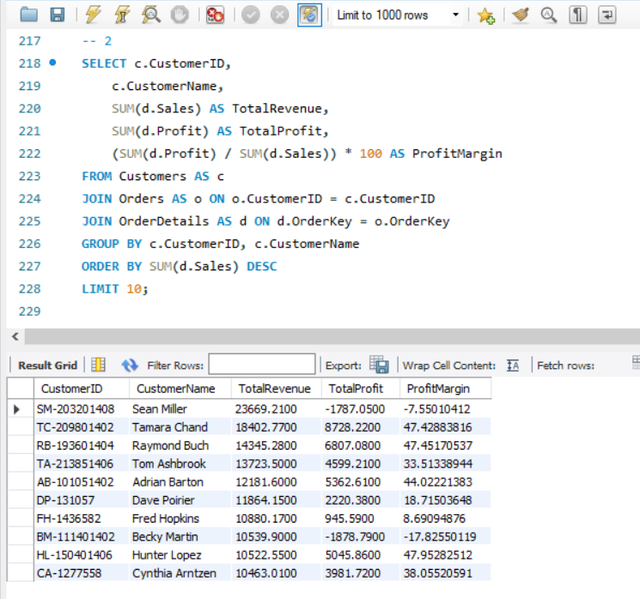
Business Insight:
From the data, we can conclude that the customers who generate the highest revenue are not necessarily the ones who bring in the most profit. Interestingly, there are even top-revenue customers, such as Sean Miller and Becky Martin, on whom the company is actually losing money due to negative profit margins. This discrepancy indicates an issue with our pricing or cost structure. It is a clear sign that we should review our shipping fees, product manufacturing costs, promotional discounts, or the specific product mix these high-volume clients are purchasing.

Which customer segments generate the most revenue and profit?
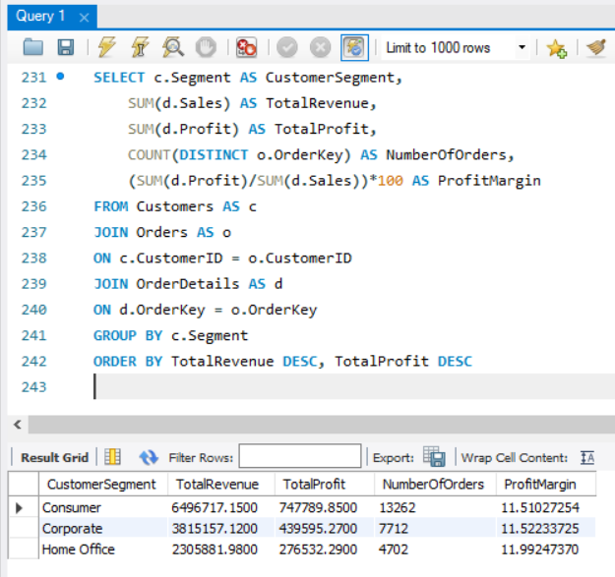
Business Insight:
Looking at the table, we can see that the Consumer segment is the biggest for our company in terms of total revenue, profit, and the number of orders. It brings in the most volume. However, the Corporate and Home Office segments are more efficient because they have higher profit margins. This means that while we sell more to regular consumers, our business clients are actually more profitable per order.

Which product categories and sub-categories are the most and least profitable?
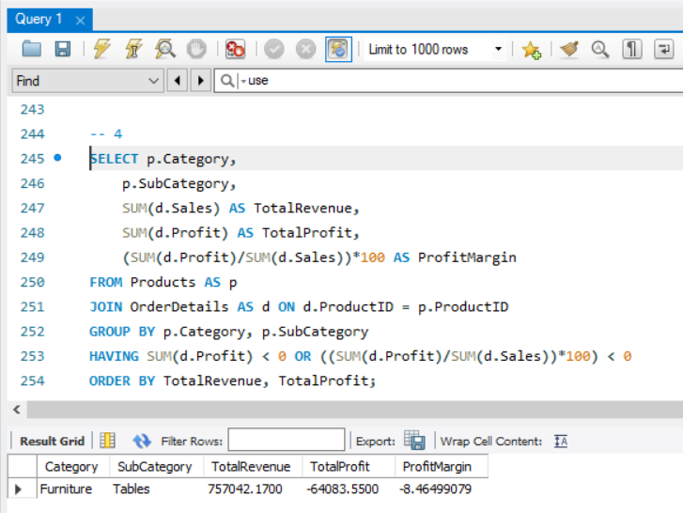

Business Insight:
Based on the query results, the Furniture category, specifically the Tables sub-category, is the least profitable area for the business. In fact, it generates a negative total profit and a negative profit margin, meaning the company is actively losing money here. We need to investigate this sub-category further to understand why tables are performing so poorly. This could be due to high shipping costs for heavy items, aggressive discounting, or low pricing.

Which products generate high sales but poor or negative profitability?
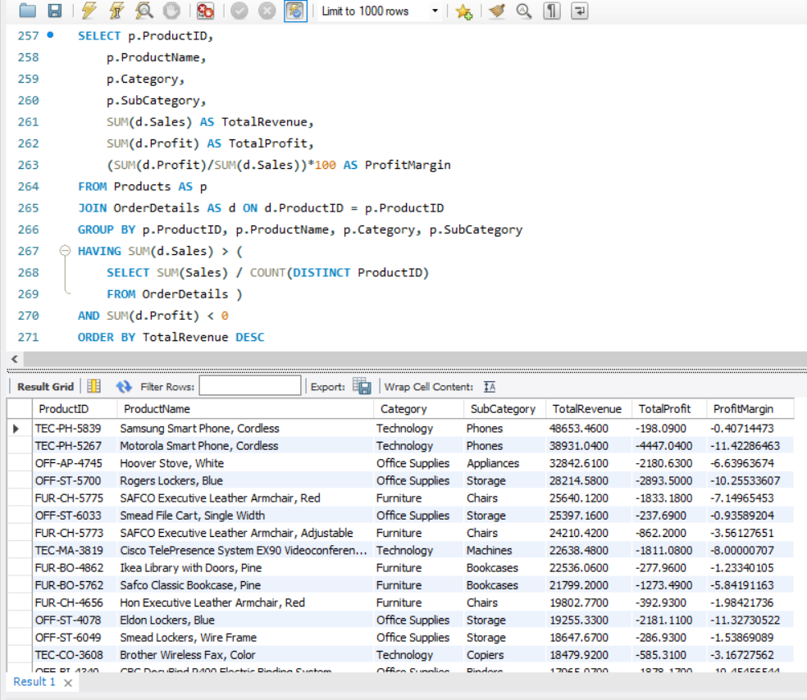

Business Insight:
From the table, we can see that many products generate above-average sales but still end up with a negative profit and profit margin. This shows that we have items with strong customer demand that are not actually making any money for the business. Therefore, we should review our overall product strategy. Additionally, because these unprofitable items belong to several different categories (like Technology, Office Supplies, and Furniture), it means the issue is widespread. We should examine each product individually rather than looking for a single reason within just one category or sub-category.

Which countries contribute the most to company revenue and profit, and are their profit contributions proportional to their revenue contributions?
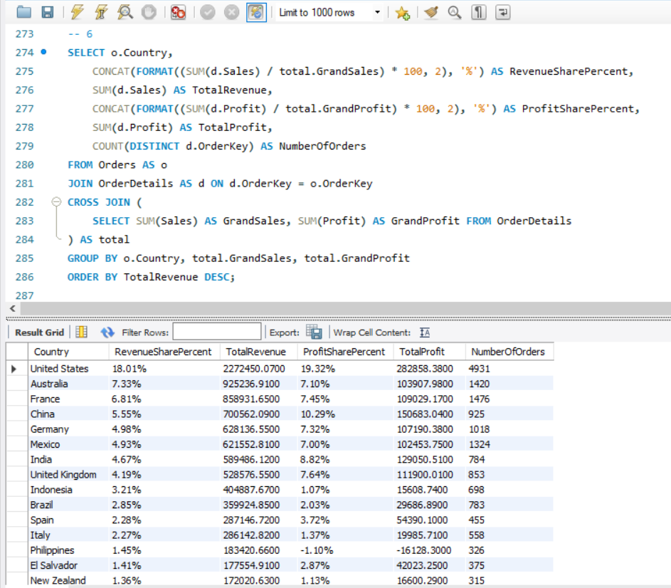

Business Insight:
The query results show the percentage contribution of different countries to our total revenue and total profit. Looking closely at the data, we can identify China and India as exceptionally strong markets for our business. Both countries contribute substantially more to our total profit than to our revenue. This indicates that our operations in these regions are highly efficient and have excellent profit margins, making them key drivers for the company’s bottom line.

How do different discount levels affect sales volume, revenue, and profitability?
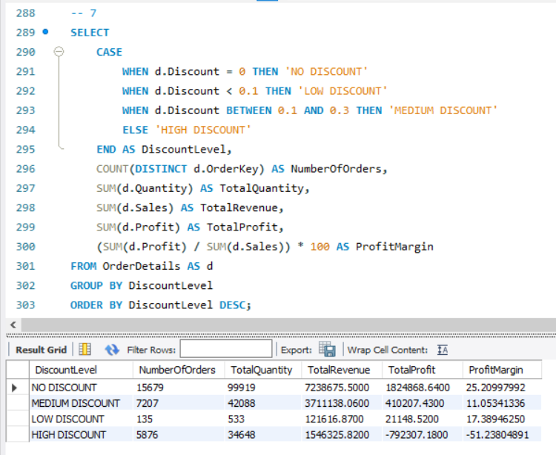

Business Insight:
I divided the discounts into four levels to see which range maximizes our profit margin and sales volume. The table shows that products sold with No Discount perform the best, generating the highest revenue, quantity, and a very healthy profit margin of 25.32%. However, the most critical finding is in the High Discount category. Even though it drives a large volume of sales, it causes a massive loss of over 793,000 and a deeply negative profit margin (-51.27%). Therefore, instead of eliminating all discounts completely, the company should immediately stop or heavily restrict high discounts, while carefully managing low and medium discounts.

Which shipping modes are the most financially efficient?
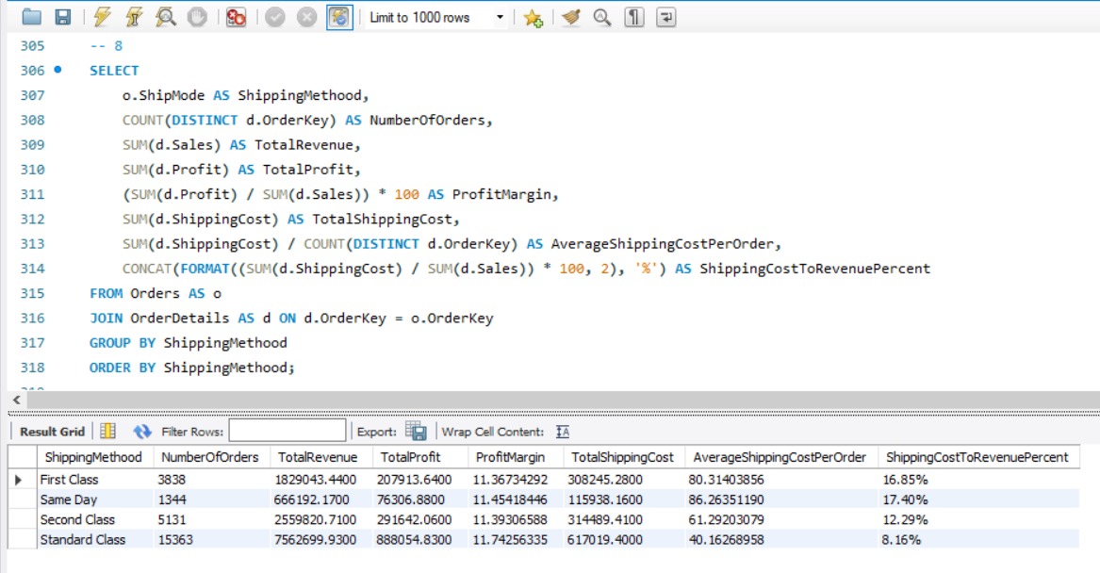

Business Insight:
From the table, we can see that Standard Class is the most cost-efficient shipping method for the company. Its shipping cost represents only about 8.15% of its revenue, and it has the lowest average shipping cost per order (40.12). On the other hand, the fastest shipping options—Same Day and First Class—bring significantly higher shipping costs, eating up 16% to 17% of their revenue. However, these premium shipping modes do not result in higher profit margins, as the profit margin stays around 11% across all categories.

What are the top 3 most profitable products within each product category?
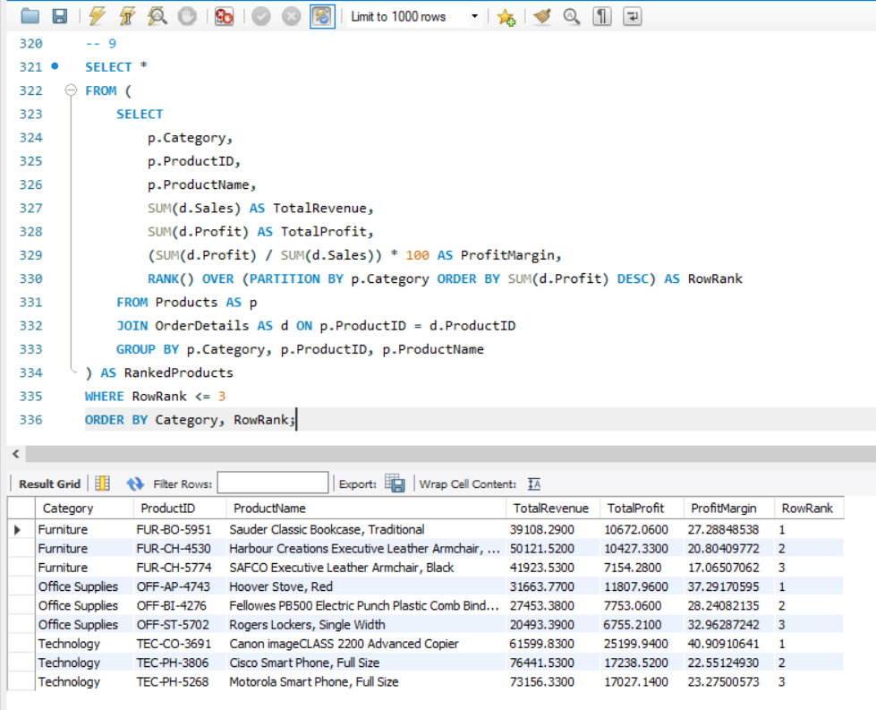

Business Insight:
This table identifies the top 3 products that generate the highest total profit within each of our main categories: Furniture, Office Supplies, and Technology. By looking closely at the data, we can see that the Canon imageCLASS 2200 Advanced Copier in the Technology category is our most successful product overall, bringing in over 25,199 in profit with a high profit margin of 40.9%. Keeping track of these top-performing items helps the company know which specific products are driving our core profitability.

Which individual sales transactions generated the largest losses, and what characteristics do they have in common?
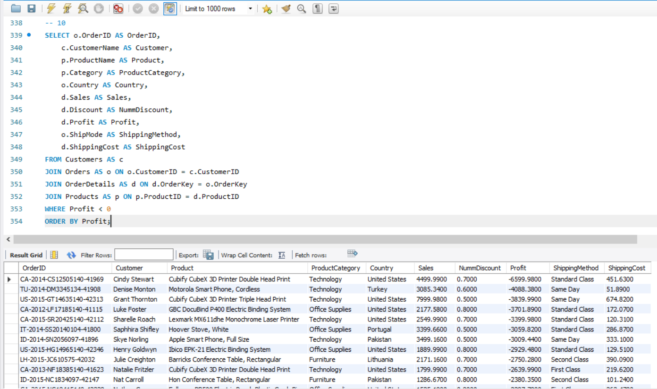

Business Insight:
This table displays the specific transactions that caused the largest financial losses for the business, along with their key details. Looking at the data, we can clearly identify a common characteristic: almost all of these highly unprofitable orders are strongly connected to very aggressive discounts. Every single top-loss transaction has a discount rate of 50% or higher (between 0.50 and 0.70). This proves that extreme discounting is the main reason why even high-value sales end up losing the company significant amounts of money.

